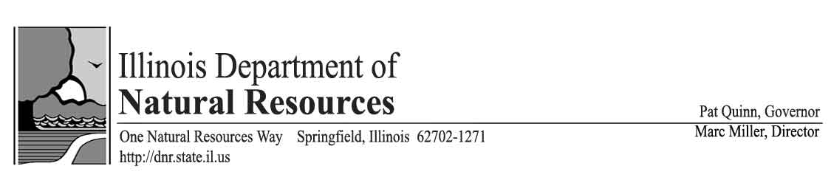
Water Conservation and Efficiency Program Review
Illinois’ Fifth Report to the Compact Council and Regional Body

December 8, 2014

Lead agency and contact person
Daniel Injerd, Chief, Lake Michigan Management Section
Illinois Department of Natural Resources, Office of Water Resources
James R. Thompson Center
100 W. Randolph St., Suite 5-600
Chicago, IL 60601

Illinois’ water conservation and efficiency program

- Status of Illinois’ Domestic Water Use from Lake Michigan

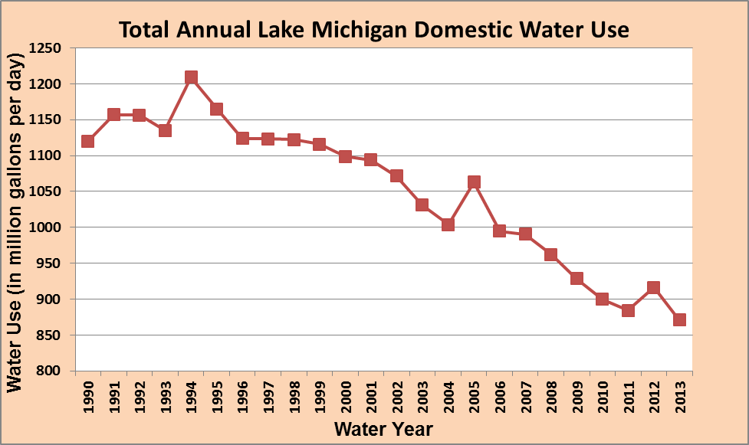

In Water Year 2013 total domestic Lake Michigan water use was 871 million gallons per day (mgd). This table clearly shows the long term decline in total domestic use of Lake Michigan water. The drought years of 1994, 2005 and 2012 are clearly visible, but the overall downward trend in water use that has occurred over the last 20 years is significant, a 300 mgd reduction since 1992. In 2013 the annual precipitation was 34.6 inches, slightly below the 23 year average of 36.7 inches.

Water use summaries for the 2010 through 2013 Water Years are on our website:
http://www.dnr.illinois.gov/WaterResources/Pages/LakeMichiganWaterAllocation.aspx. This information was obtained from the Annual Water Use Audit Reports (LMO-2), and is reported to the Great Lakes Regional Water Use Database

- Program Legal Basis

The U.S. Supreme Court Decree [Wisconsin v. Illinois, 449 U.S. 48 (1980)] that limits Illinois’ diversion of Lake Michigan water also contains language directing Illinois to implement a water conservation program. The Level of Lake Michigan Act [615 ILCS 50] incorporates the Decree language which states that:

“all feasible means reasonably available to the State and its municipalities, political subdivisions, agencies and instrumentalities shall be employed to conserve and manage the water resources of the region and the use of water therein in accordance with the best modern scientific knowledge and engineering practice.” [615 ILCS 50/5)]

This is the operative judicial and statutory language that directs the Illinois Department of Natural Resources (Department) to develop and implement a water management and conservation program covering all permittees of Lake Michigan water.

- Program Objectives

In 2010, the Department developed and posted on our website Illinois’ Lake Michigan Water Conservation Goals and Objectives, as required by the Compact and the Regional Agreement. http://www.dnr.illinois.gov/WaterResources/Pages/LakeMichiganWaterAllocation.aspx
The Department’s water conservation and efficiency program objectives are:

- Enforce the adoption of standards that require the efficient use and conservation of Lake Michigan water by the end user (homeowner, business/industry).
- Establish standards for good water system management and leakage control by the owner/operator of a water supply system.
- Ensure that Lake Michigan water diverted directly into the Chicago Waterway system for various purposes is kept to a minimum.
- Collect water use data annually; monitor changes in water use patterns. Encourage public water supply systems to evaluate the effectiveness of their conservation efforts.
- Prepare and maintain long-term water demand forecasts.
- Promote the adoption of water rate structures that encourage conservation and water efficiency.
- Encourage water suppliers to invest in water infrastructure and the use of innovative technology to improve water systems management.
- Encourage research, development and implementation of water efficient technologies. Develop linkages with organizations such as USEPA’s WaterSense Program, the Alliance for Water Efficiency and others, to keep abreast of the latest conservation technologies.
- Inform, educate and increase awareness regarding water use, conservation and efficiency via newsletters and other such means of communication.
- Work with our Lake Michigan water allocation permittees and our Great Lakes basin partners to enhance information sharing.

- Program Activity – Updating Administrative Rules

This has been a major program activity for the Department over the last 5 years, and especially in 2014. Updating the Lake Michigan Water Allocation Rules and Regulations, which were first adopted back in 1980, is a significant undertaking, and has included several lengthy public review and comment periods. More recently, on March 7, 2014, proposed changes to the Rules and Regulations for the Allocation of Water from Lake Michigan (IL Admin. Code, Title 17, Part 3730) were published in the Illinois Register. This began the official rulemaking process. An initial 45 day review and comment period was extended an additional 30 days until May 12, 2014. The Department responded to the comments received during the notice period, and in response made several minor changes to the proposed rules. The new rules should become final before the end of this year.

The updated Lake Michigan water allocation rules will improve Illinois’ water conservation and efficiency program. Here is a very brief summary of the substantive changes to the rules.

- Since 1977 the Department has had an ‘Unaccounted-For-Flow’ standard for all domestic Lake Michigan water supplies. This standard will be replaced with a ‘Non-Revenue Water’ standard, which will allow public water supplies to utilize the water audit methodology recommended by the American Water Works Association (AWWA M36 water audit methodology), and to better track the value of water loss.
- Water systems not in compliance with the non-revenue standard will be required to prepare and submit a water system improvement plan.
- Local/Municipal plumbing codes/ordinances will be updated to require that new and replacement plumbing fixtures be a labeled WaterSense product.
- The classification system has been revised so that a water applicant that utilizes deep aquifer groundwater is a higher priority use than the use of water from Lake Michigan to meet navigation requirements and minimum discretionary dilution flows necessary to maintain the CAWS in a reasonably satisfactory sanitary condition.
- Additional guidelines for lawn sprinkling have also been included, as well as recommendations for sub-metering in new multi-family building construction where practicable and feasible and setting water rates to reflect full cost pricing.

Guidance for Preparing Water System Improvement Plans

The focus of this rule change is to be a catalyst to assist communities in addressing water loss problems, utilizing the best methods of water accounting and loss reduction. A water system improvement plan will be a locally developed plan of action that identifies the causes of water loss, what measures need to be implemented to reduce water loss and an estimated timeframe to implement those measures.

The Department has contracted with the Chicago Metropolitan Agency for Planning to prepare guidance materials to assist communities that will need to prepare a water system improvement plan. The Department is also working with the Illinois Environmental Protection Agency, who has retained the Illinois Section of the American Water Works Association and the Illinois Rural Water Association to conduct at least 35 water loss audit training sessions throughout the state, including at least 12 within the Lake Michigan water service area. This will be an excellent opportunity to take advantage of their expertise in water audit methodology.

- Program Activity – Lake Michigan Water Allocation Newsletter

The Department’s most recent newsletter was distributed in September 2014, and is available on the Lake Michigan Water Allocation homepage: http://www.dnr.illinois.gov/WaterResources/Pages/LakeMichiganWaterAllocation.aspx
The newsletter, in addition to containing timely information concerning the Lake Michigan water allocation program, also includes a summary of water use for the most recent Water Year. The newsletter has been one of the primary means utilized to communicate with Lake Michigan water systems.

- Program Activity – Develop Linkages with other Conservation Organizations

During this past year the Department’s has continued and has developed several new partnerships with other groups/organizations to further our water conservation program efforts. These include:
- Maintaining our membership in USEPA’s ‘WaterSense Partner’ program and updating our rules to require the use of ‘Water Sense’ labeled plumbing fixtures as our standard for water efficient plumbing fixtures.
- Working with regional organizations such as the Chicago Metropolitan Agency for Planning, the Northwest Water Planning Alliance, the Northeastern Illinois Regional Water Supply Planning Group, the Center for Neighborhood Technology and the Metropolitan Planning Council to further our outreach to communities in the areas of water supply planning, drought management, water loss control and sustainable water resource management.
- Working with the Illinois Environmental Protection Agency (IEPA) to better integrate our water conservation program with their administration of Governor Quinn’s Clean Water Initiative Fund, a $1 billion low interest loan fund that significantly expands Illinois’ State Revolving Fund. These funds are available to help Illinois communities improve their water and wastewater infrastructure, and will be particularly useful for Lake Michigan communities that need to upgrade their water infrastructure in response to our new non-revenue water thresholds.
- Work with the Illinois Section AWWA, the IEPA, the Illinois Rural Water Association and others to develop and hold at least 35 water loss control workshops throughout the state beginning in the fall of 2014.

- Program Activity – Water Rate Survey

The Department recommends that Lake Michigan water providers adopt water rate structures that 1) are based on metered water use, 2) discourage excessive water use, and 3) reflect the full cost of water, including the long term cost to properly maintain and operate the water supply distribution system in such a manner as to keep system losses to a minimum.

Our long term practice has been to undertake a water rate survey of all Lake Michigan water providers every 5 years. Our last water rate survey was published in 2010. Since then it has become apparent that water rates have been increasing steadily and a 5 year cycle is no longer able to keep pace with water rate changes. Over half of our Lake Michigan water systems purchase water from the City of Chicago, which increased its water rate, effective January 1, 2014 to $3.32/1000 gallons, and which will rise to $3.82/1000 gallons effective January 1, 2015. Ten years ago Chicago’s rate was only $1.26/1000 gallons.

Our next 5 year water rate survey will be in 2015. Our goal thereafter is to collect water rate information every year as part of our annual water use audit reports.

- Program Activity – Water Use and Water Loss Monitoring

Water loss information was again collected in 2013 and 2014, utilizing the reported unaccounted-for-flow (UFF) of all our domestic Lake Michigan water suppliers. In 2013, the average UFF in the Lake Michigan water service region was about 5.5%, a slight increase over that reported in 2012.

Concerned with the number of communities that continued to struggle with high rates of water loss, in 2013 the Department entered into a Memorandum of Agreement with the Chicago Metropolitan Agency for Planning to utilize their Local Technical Assistance program to conduct an analysis of the obstacles and constraints faced by public water supplies in managing/minimizing water loss. The Center for Neighborhood Technology also collaborated on this project. Their analysis and recommendations were presented to the Department in a July 2014 report titled “An Assessment of Water Loss Among Lake Michigan Permittees in Illinois”, and can be accessed at: http://www.cmap.illinois.gov/programs-and-resources/lta/idnr. Their analysis confirmed that water loss is becoming more pervasive throughout the Lake Michigan water service area, and that the allowance for maximum unavoidable leakage was masking the severity of actual water loss. They also found that 74% of our permittees have no formal water loss control policy.

The report supports the proposed changes to the water allocation rules that will switch to a non-revenue water threshold/water audit accounting system utilizing the AWWA M36 methodology. This water audit methodology will provide good information on the value of lost water, and supports our goal to encourage our permittees to operate, maintain and upgrade water system infrastructure to promote the efficient use and conservation of Lake Michigan water.

Prior to the approval of our updated administrative rules in late 2014, the 2013 and 2014 Annual Water Use Report forms were modified to allow our domestic permittees to estimate and report the value of their non-revenue water. Combining the total amount of unaccounted-for-flow and maximum unavoidable leakage will approximate a non-revenue water quantity, and by using their wholesale cost of water they can develop a conservative estimate of the value of lost water. This is the first time we are asking our permittees to translate their water loss data to a dollar amount, which should serve to illustrate the value of undertaking infrastructure improvements to a water system.

- Program Activity – Control of Direct Diversion into Chicago Waterway System

The total amount of Lake Michigan water diverted into the Chicago Waterway System for discretionary diversion and navigation makeup flow was 304.1 cubic feet per second (cfs) in water year 2013. At the end of the 2013 water year, the five year running average of these two components of direct diversion stands at 294 cfs, or 11 cfs below the combined allocation (305 cfs) for these two components of direct diversion. The Metropolitan Water Reclamation District of Greater Chicago holds the Lake Michigan water allocation for both discretionary diversion and navigation makeup.

The other primary use of Lake Michigan water diverted directly into the Chicago Waterway System is to operate the navigation locks at the mouth of the Chicago River and on the Calumet River. Both of these lock facilities are operated and maintained by the U.S. Army Corps of Engineers. Illinois does not have any control over the amount of water diverted for lockage or for leakage through these structures, although this water is included in the accounting for Illinois’ diversion under the U.S. Supreme Court Decree. Lake Michigan water levels have a significant impact on the amount of water diverted for the operation of the navigation locks.

- Project Activity – Status of Water Demand Forecasts and Water Use

In 2008, the Department completed a comprehensive water reallocation for all our water supply permittees. As part of this reallocation, water demand forecasts for each year, out to the year 2030, were developed and ultimately included in the Department’s updated Lake Michigan water reallocations. A primary reason for this long timeframe is to ensure that the Department’s water allocation program is sustainable over the foreseeable future, and will continue to keep Illinois’ total diversion below the authorized U.S. Supreme Court Decree limit of 3200 cfs. It is anticipated that sometime during the next 5 years the Department will undertake another comprehensive water reallocation and extend allocations out to at least the year 2040.

During this past year the Department has not issued any new water allocations; two new water allocation requests are currently pending.

- Project Activity - Water Infrastructure

In the fall of 2013 the City of Chicago released a report entitled “2015 Sustainable Chicago”, http://www.cityofchicago.org/city/en/progs/env/sustainable_chicago2015.html which outlines a number of major initiatives the City plans to undertake with the overall goal of becoming a more sustainable city. A major component of this report is the City’s commitment to upgrading their water, wastewater and stormwater infrastructure. They expect to achieve a 2%/year reduction in water use from this effort.

A number of other Lake Michigan communities have also developed, or are working on conservation/sustainability initiatives. The northeastern Illinois region has a number of organizations who work with local government to help them become more sustainable. These initiatives are also moving outside the Lake Michigan water service region..

Conclusion

Illinois has had a Lake Michigan water conservation and efficiency program for over 30 years. Our program is consistent with and fully supports the Great Lakes-St. Lawrence River Basin Water Conservation and Efficiency Objectives. The unique nature of Illinois’ Lake Michigan water use and diversion as allowed under a U.S. Supreme Court Decree has resulted in a water conservation and efficiency program that is implemented primarily as a regulatory program, with additional measures, such as conservation pricing, conservation education and information sharing, implemented through a non-regulatory effort.

